CS 255 System Design Document Template

UML Diagrams

UML Use Case Diagram
The system boundary and user roles below reflect the client interview. The diagram identifies the system boundary, user roles, and functions requested by DriverPass.
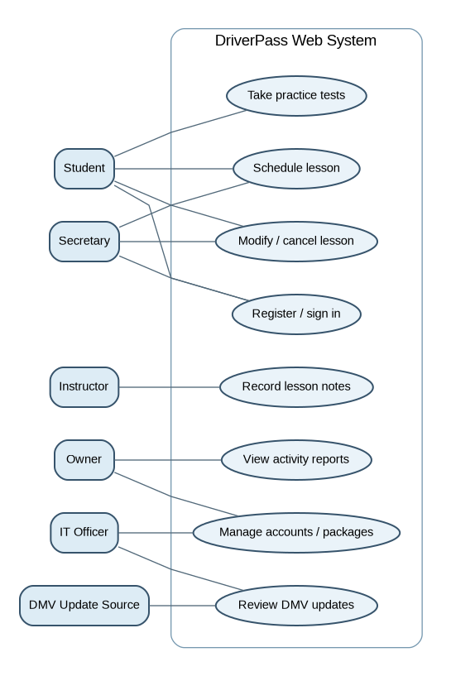

UML Activity Diagrams
Two workflows are modeled: reserving a two-hour lesson and changing or canceling an existing reservation. Decision points prevent double booking and record modifications.
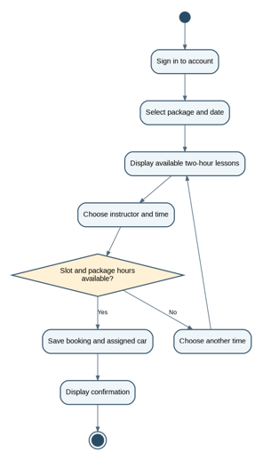 | 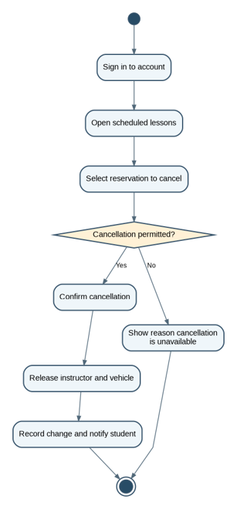

UML Sequence Diagram
The booking interaction coordinates the website, booking service, schedule database, and audit record. The availability check and reservation save must be performed together to prevent conflicting bookings.
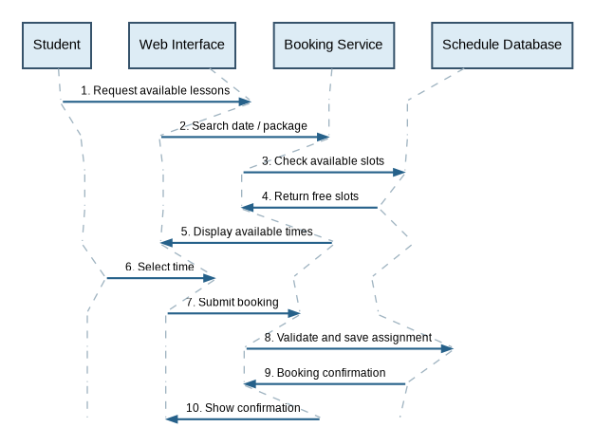

UML Class Diagram
Core classes separate accounts, package enrollment, lessons, vehicles, test progress, notes, and change history. Multiplicities show how many related records may exist. Payment card details are deliberately not stored in these application classes.
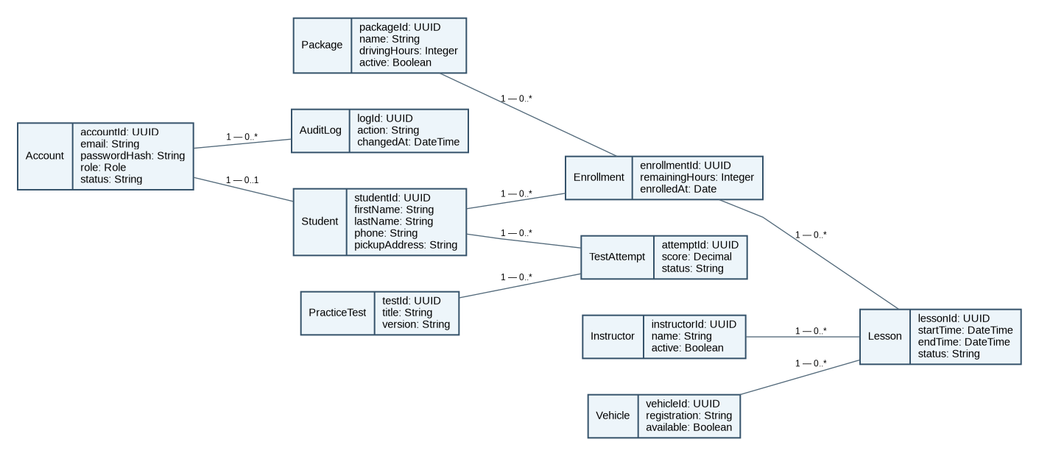

Technical Requirements
Hardware and infrastructure. Deploy a responsive web application on a managed cloud platform with managed relational database, automated encrypted backups, monitoring, and disaster-recovery procedures. Customers and staff use standard browsers on phones or computers; instructors can access schedules on mobile devices. Reliable internet is required for live changes. Exported CSV/XLSX reports may be viewed offline, but edits to downloaded copies do not synchronize automatically.
Software and tools. Implement the interface using a maintained web framework and accessible responsive layouts. Use a server-side application/API for scheduling, authentication, package enrollment, tests, reporting, and audit history; use a relational database with foreign keys and transactional booking operations. Developers use Git version control, a testing framework, database migration tools, and cloud deployment/monitoring tools. Lucidchart diagrams document design rather than run the system.
Scheduling and packages. Enforce exactly two-hour lessons and prevent overlapping instructor and vehicle assignments in a single transaction. Track the student, instructor, car, date/time, pickup and matching drop-off location, booking status, and creator/editor. Support Package One (6 driving hours/3 lessons), Package Two (8 hours/4 lessons plus in-person instruction), and Package Three (12 hours/6 lessons plus in-person instruction and online classes/practice tests). Allow the owner to deactivate packages for new enrollments without deleting existing purchases. New package/module creation is a later enhancement.
Accounts and permissions. Provide secure registration, login, self-service password reset, and role-based access: students manage their own appointments and progress; secretaries manage customer registration and bookings; instructors see assignments and enter lesson notes; the owner views reports and package availability; IT manages accounts and disables access. Log the user, action, timestamp, and affected reservation for creation, edits, and cancellation. Protect reports and personal records from unauthorized users.
Training, reporting, and updates. Provide online class materials and practice tests, including test title, time taken, score, and not-taken/in-progress/failed/passed status. Display lesson time, start/end time, and instructor comments. Provide printable and Excel-compatible reports, contact information, and a means to contact students. Provide a configurable DMV update intake/notification process; a live automatic feed depends on an authorized DMV integration being available.
Security, resilience, and payments. Require HTTPS, encryption at rest, password hashing, least-privilege permissions, input validation, audit-log protection, backup restoration testing, and session timeouts. Use a PCI-compliant payment processor to tokenize payment details; do not retain card security codes. Cloud service monitoring and recovery procedures address uptime and data protection, but service interruptions and internet outages remain possible.
Design assumptions and limits. Exact payment workflows, cancellation policies, staff assignment rules, training-content formats, and the DMV integration method were not specified in the interview and require client confirmation before implementation. The diagram models a feasible proposed solution, not an existing implemented system. No offline booking edits or nondeveloper creation of new training modules is included in the first release.

